CONCEPT BUSINESSPLAN


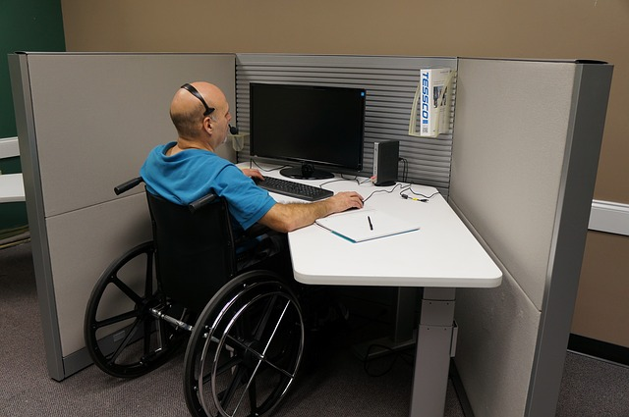
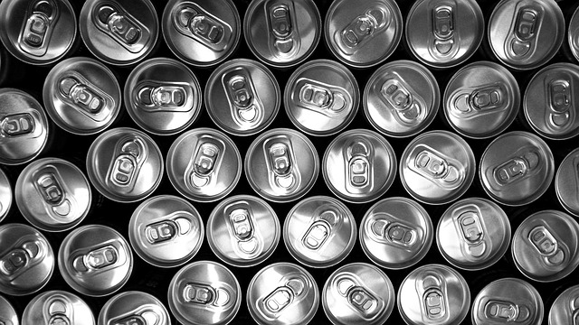
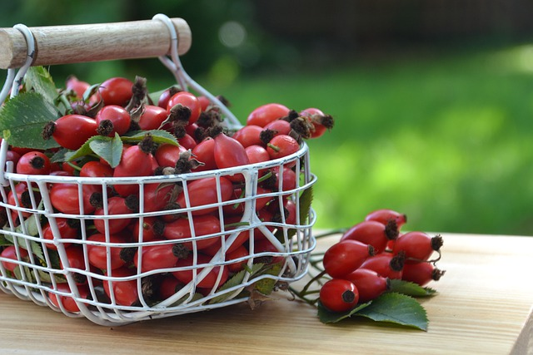
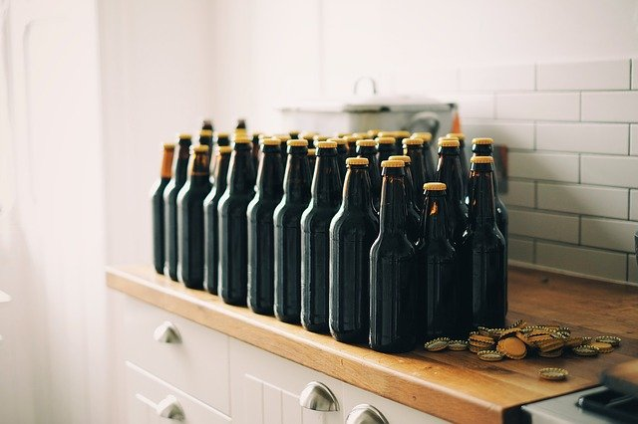

Businessplan; DisabledBeer.com

“A specialty beer with medicinal herbs for the good cause”

“For a better and nicer life of disabled people”

“A pilot in the United States”

Organization: DisabledBeer.com / DisabledFund.org / WajongConcern.Trade
Place: Sittard, The Netherlands
Author Ferdinand Pot
Date: September, 2023

CONTENT

Businessplan:

1 The company / organization
1.1 Business details
1.2 The product
1.3 Mission and goals
1.4 Housing
1.5 Legal form
1.6 Government
1.7 Insurances
1.8 The entrepreneur(s)

2 The market
2.1 Industry analysis
2.2 Customer analysis
2.3 Competition analysis
2.4 Supplier analysis
2.5 Distribution analysis
2.6 Environment analysis
2.7 Internal analysis
2.8 Marketingstrategy

3 Promotion
3.1 Target audiences
3.2 Corporate identity
3.3 Website
3.4 Promotion plan

4 The organization
4.1 Personnel and authorizations
4.2 Production process
4.3 Automation / computerization
4.4 Accountancy and administration

5 Finance
5.1 Sales forecast
5.2 Investment budget
5.3 Financing plan
5.4 Opening balance
5.5 Balance sheet results
5.6 Liquidity budget
5.7 Scenario analysis
5.8 Income entrepreneur(s)

6 Attachments

1 The company / organization
1.1 Business details
DisabledBeer.com / DisabledFund.org / WajongConcern.Trade
Ferdinand Pot
François de Veyestraat 8B
6221 AB Maastricht
Internet: http://www.disabledbeer.com/
E-mail: info@disabledbeer.com
1.2 The product
The product / idea is to make a nice specialty beer with medicinal herbs added and sell these products to retail stores/chains. In the beginning we will concentrate on retail stores / supermarkets in the United States of America We will start with a pilot in the USA. When it will be successfull other countries / markets can be taking into account.

The specialty beer will be packaged in a special, (ecological) and nice packaging to offer this to the customers from the (big) retail chains in the USA. The specialty beer will be sold on the brandname: “DisabledBeer.com”. A small percentage of the sold specialty beers will go to the “DisabledFund.org” organization.

This organization will develop in the future projects for the disabled community worldwide to improve their lives (quality of life). This when there will be enough money to create a “registered fund”. The projects that this organization will execute will be a radio-website for disabled people, a newspaper-website for disabled people, a magazine-website for disabled people and a video-website for disabled people. More projects could be added later if there is enough money etc.

The “DisabledFund.org” organization will be something like the Dutch organization “WajongConcern.Trade”. They have their own website, which is www.wajongconcern.trade . Here you can find more information about the projects.

So the project is about selling a specialty/craft beer for the good cause. First we will start on the market in the USA. The internet addresses of the (big) retail chains in USA, you can find these at chapter 6 (Attachments) in this businessplan.

Also we did some small market-research in the United States about this specialty beer. The insights that we did get from this small market-research are:

– 42,9 percent answered that they buy three times a month beer.
– To make a video-website for the disabled people has the most preference from the respondents.
– Around 90 percent of the respondents answered that they would buy a package of six bottles from 0,33 liter to support the disabled community.

All the insights / results from this small market-research can be found in chapter 6 from this businessplan (Attachments).
Already thanks for your time to take a look at this special businessplan. Thanks again!
1.3 Mission and goals
The mission of the DisabledBeer.com organization is to collect money (fundraiser) for the good cause projects for the DisabledFund.org organization. Projects where you can think of are a newspaper-website for disabled people, a magazine-website for disabled people, a radio-website for disabled people and a video-website for disabled people. The website “DisabledBeer.com” will link to these websites in the future. These websites will improve the lives (quality of life) of the disabled people worldwide. A small percentage (like ten percent) of the sold specialty beers, goes to the DisabledFund.org organization. The other profits can goes to other good causes or to the private label manufacturer.

1.4 Housing
For the housing for the “DisabledBeer.com” organization which will work close with the “DisabledFund.org” organization we will look in the future for a cheap office at a multi-company building in the Maastricht area in The Netherlands. Perhaps there will be a cheap office to rent in the Maastricht area in The Netherlands. We choose for the Maastricht area, because the city Maastricht is very “international” orientated. The cost of the office rental is approximately estimated around 3.000 euro's per year. This will be paid after there is enough money fundraised for the “registered fund” for the “DisabledFund.org” organization. The rent will be paid from the registered fund earnings. When there is enough space in the rented building, and there is a small kitchen we will also try to make our own beer recipes and taste them. This perhaps with unique “medicinal herbs” or other ingredients to make a unique beer. When we discover a unique and tasteful recipe we will send this to our private label manufacturer, zo that they can brew the beer on a large scale.

1.5 Legal form
There will be no legal form for the “DisabledFund.org” organization. All the income will come from the “registered fund”. The best way to describe the “DisabledFund.org” organization is as a private volunteer initiative. We will get a insurance at a insurance company for all the volunteers. The volunteer insurance services is estimated about 12 dollar per volunteer per year (Source: insurancequotes.com). When there is “public” insurance then we will use this, but we have to check this.
1.6 Government
You do not need a permit from the United States governement to develop a new specialty/craft beer for the USA market. There are some requirements from the USA government about packaging and labeling food products. Also there are some requirements about producing safe food products. The internet can give more information about these topics. There are also some rules about paying excise duty for the alcohol of the specilaty/craft beers and value added tax (VAT), the internet can give more information about these topics.
1.7 Insurances
We want to work with a “private label” organization, and they have already the right insurances. But we have to check this, so that we know this is for sure. We think to work with a private label manufacturer. They are several private label manufacturers-breweries in the United States (USA).
1.8 The entrepreneur(s)
We will look for volunteers that can make promotion for the “DisabledBeer.com” formula/concept. They must have “entrepreneurial” skills. If they have not the right skills yet, we perhaps can help them. There is a cheap e-learning platform called “Udemy.com”. This e-learning platform provide a lot of online courses about promotion/marketing/entrepreneurship. It is possible to start a online course for a cheap price from around 20,- dollar per online course. There is just one requirement to the entrepreneurs/volunteers is that they understand the English language a little bit.
2 The market
2.1 Industry analysis
Underneath you can find some points for attention regarding the industry analysis for the “DisabledBeer.com” organization:
2.1.1 Industry
The industry can be described as the “beer-market” in the United States of America. We searched on the internet and found some interesting information. The volume of beer sales in the United States is around 116 billion dollars a year (Source: brewersassociation.org). The sales of craft beer increased 6 percent to 29,3 billion dollar in the United States(Source: brewersassociation.org).

2.1.2 Attractiveness market
The “attractiveness” of the USA beer-market we can describe this market as “normal attractive”. Not very attractive and also not “not-attractive”. We made this statement because customers like more and more “healthy” and “ecological” products. But the market can be described still as attractive because the market is big and has a sales volume of billion's of dollars. Private label opportunities are offered by several private label manufacturers/breweries in the United States.
2.1.3 Total market demand
The “beer-market” in the United States had in the year 2019 a production around of 25.000.000 barrels. (Source: brewersassociation.org). One barrel is 31 US gallons. And one gallon is around 4 liter. So we talk about a large production of all kinds of beer in the United States. So the total market demand is about million's for the USA-beer-market. With these numbers we can conclude there is enough “space” on the beer-market to introduce a new specialty/craft beer for the USA customers.
2.1.4 Cost structure
We do not have the exact “numbers” of the cost structure of the beer-market in the United States of America. We searched on the internet and found at a Dutch brewery website that the cost-price for a specialty/craft beer is between 2,10 euro and 2,75 euro per liter. This cost-price is inclusive excise duty, VAT excluded, filled beer, with label, with cap and packaged in a box (Source: loonbrouwerij.nl)
The “DisabledBeer.com” organization would operate with a low cost structure. We want to work with volunteers. This will keep the personnel-costs very low. Also we keep an eye on spending money. We will be the “marketeers” of the “DisabledBeer.com” concept/formula on this planet!
2.1.5 Market leaders
The market leaders / big players for the global beer-market are the breweries “AB InBev” and “Heineken”. “AB InBev generated in the year 2019 more than 54 billion U.S. dollars in revenue worldwide (Source: statista.com). The Dutch brewing company “Heineken” did get in the year 2019 a revenue from around 26,5 billion in U.S. Dollar from “beer-sales” (Source: statista.com). These company's are the big players/market leaders of the “beer-market” when we look globally.

2.1.6 Ease of accession
The convenience of accession of the USA beer-market looks easy. There are several “private label” manufacturers for (specialty) beers in the United States of America. It looks very easy to access the USA beer-market with their help.
2.1.7 Competition
If you take all beers into account on the USA beer-market, there is a lot of competition. You only have to visit stores in the USA and look at the beer category in the store. The competition can be described as very high. But for a specialty beer “with a story and a good cause” there must be some space on the shelf in some retail stores.
2.1.8 Importance of the market
The importance of the beer market in the United States of America can be descibed as “important”. For this market we talk about in the year 2019 a amount of production of 214 million hectoliters (Source: wikipedia.org). The export form the United States to other countries was in the year 2019 3,535 million hectoliters (Source: wikipedia.org). The import of beer to the United States was in the year 2019 33,731 million hectoliters (Source: wikipedia.org). The beer consumption in the United States was in the year 2019 244,85 million hectoliters (Source: wikipedia.org). The beer consumption per inhabitant of the United States was 78,2 liter in the year 2019 (Source: wikipedia.org). And in the United States there were in the year 2019 2100 active breweries (Source: wikipedia.org) This all is a lot so we can describe the beer-market in the United States of America as “important”.
2.1.9 Laws and rules
For the labelling and packaging for the “DisabledBeer.com” products, there are some laws/rules from the USA government/Food and Drug Administration (FDA). These rules concern about several topics for prepackaged food products. More information about this topic can be found at the website www.fda.gov . Next to this there are some laws/rules about food manufactering and hygiene. These laws/rules can also be found at the website www.fda.gov .

2.1.10 Changes in the market
There are some changes in the market / world. Consumers like more ecological packaging. This for the environment. Next to this biological ingredients are also prefered by consumers. This are two points to take into account for the future.
2.1.11 Substitute products
When we talk about “substitute products” for a specialty beer, you can think of normal beer Also you can think of several liquor drinks as a substitute product. For non-alcoholic beers you can think of several soft drinks as a “substitute product”.
2.2 Customer analysis
Underneath you can find some points for attention regarding the customer analysis for the “DisabledBeer.com” organization:
2.2.1 Potential customers (extern and intern)
The potential customers (extern) for the “DisabledBeer.com” organization can be described in eight kinds of customers. Underneath you can find a descripiton of these (extern) potential customers for the “DisabledBeer.com” / “DisabledFund.org” organization:

-1- People with mobility and physical impairments

-2- People with spinal cord disability

-3- People with head / brain disability

-4- People with a vision disability

-5- People with a hearing disability

-6- People with a cognitive or learning disability

-7- People with psychological disorders

-8- People with invisible disabilities
This eight potential customer groups are the target audience in the United States of America. There are about 61 million people that collect Social Security benefits each month (Source: nasi.org). Also it is the fact that in the United States of America in about one family in four, someone is receiving Social Security benefits (Source: nasi.org).
-9- Volunteers (intern customers), These can be retired people or other volunteers who can help with the several websites for the DisabledFund.org organization, this including the website “DisabledBeer.com”.
2.2.2 Types of customers
Underneath you can find a description about the “types” of customers we can possible face in the future for the DisabledBeer.com concept/formula:

-1- Regular / daily customers with a disability. These people want to support the several websites of the DisabledFund.org organization. They know self what it is to live with a disability and are ready to buy a package “DisabledBeer.com” or one can or bottle in stores in the USA.
-2- Regular / daily customers without a disability. These people also want to support the DisabledFund.org / DisabledBeer.com organization. They do not have a disability by them self, but they found it be great to support the disabled community worldwide.
-3- Valentine customers. These people like Valentine's day and want to buy for this special occasion a (special) “DisabledBeer.com” packaging.
-4- Eastern customers. These people like Eastern and want to buy for this special occasion a (special) “DisabledBeer.com” packaging.
-5- Christmas / Holidays gift customers. These people like Christmas and the Holiday season and want to buy for this special occasion a (special) “DisabledBeer.com” packaging.
2.2.3 Group size
The group size for the “DisabledBeer.com” / “DisabledFund.org” organization are in first sight all the people in United States of America older then the age of 21 years. We searched on the internet and a website did show us that there are 196,899,193 people that fits this criteria (Source: infoplease.com). We want with searchengine marketing and SEO / linkbuilding volunteers reach a lot of these people with a nice “DisabledBeer.com” website.
2.2.4 Buying behavior
The “buying behavior” can be described as “good”. We did some small market-research and on the question: “Would you buy a package of six beer bottles from 0,33 liter to support the disabled community?”, around 90 percent of the respondents answered that they would buy a package of six bottles from 0,33 liter to support the disabled community. So that is good to know!
2.2.5 Utility and image

The utility of the “DisabledBeer.com” concept/formula is that we have a source of financing for the “registered fund”, called the DisabledFund.org organization. In this way the “registered fund” can grow financially. With this money we can set-up, promote and maintain the websites for a better and nicer life (quality of life) of disabled people worldwide. We want to set-up a online magazine for disabled people, a online newspaper-website for disabled people, a radio-website for disabled people and a television/video website for disabled people. The “registered fund” plays a important financial role in this. This to pay all the bills for the websites etc. The image that we want to establish is “thrustworthy” “helpfull” and “informative”, and maybe more in the future.
2.2.6 Moment of buying
Het moment of buying a package of specialty beers ore one can specialty/craft beer are the regular opening hours of the several stores in United States of America. This can be in the morning, afternoon or the evening. This for the “regular needs” of the several customers in the United States of America. For the “Holidays” customers, they can buy more packages of the specialty/craft beers or one can in the stores in the USA for “Holiday gifts”.
2.2.7 How does the customer buy
The customer will buy the “DisabledBeer.com” products with pleasure. Because they can support the good cause, the “DisabledFund.org” organization, which will create websites for a better and nicer life (quality of life) of disabled people worldwide. The customers will buy the product with pleasure by USA stores. They can buy with pleasure in the USA stores or online in the webshop of the retailer/store when this is possible.
2.2.8 Catchment area

The catchment area for the “DisabledBeer.com” / “DisabledFund.org” organization is the country “the United States of America” (USA). Hereby we focus on people at the age of 21 or elder. A website did show us that 196,899,193 people in America fits this criteria (Source: infoplease.com). This “catchment area” is large enough to sell enough specialty/craft beers on this market.
2.2.9 Trends
A trend is that social media and internet get more and more a important role in the society. We want to respond on this trend by creating a good website on the domain http://www.disabledbeer.com/ . Also we want to create a nice website for the “DisabledFund.org website. Next to this we will advertise the product on social media in the future.
2.3 Competition analysis
Underneath you can find some aspects about the competition analysis for the “DisabledBeer.com” concept/formula:
2.3.1 Direct competitors

There are not much direct competitors that offers a unique specialty/craft beer that are direct related to a good cause. The most (specialty) beers are sold for profit mainly. The “DisabledBeer.com” concept is different. We want to sell specialty/craft beers for mainly the good cause (charity). The charity is the “DisabledFund.org” organization which will realize interesting websites for disabled people worldwide, so that they get a better and nicer life (quality of life). A small percentage of the sold “DisabledBeer.com” beers will go the “DisabledFund.org” organization.

2.3.2 Number of competitors

There are a lot of competitors for the “DisabledBeer.com” concept/formula, when you look at the mainstream of beers at the shelfs of stores in the United States of America (USA). We found on the internet some information that there were 2100 active breweries in the year 2019 in the United States that makes different kind of beers (Source: wikipedia.org). That is a lot. But we have a special asset and that is that a small percentage of the “DisabledBeer.com” concept/formula goes to a good cause/charity, the “DisabledFund.org” organization. So that the “willingness to purchase” of the “DisabledBeer.com” beers will be good. That is our distinctiveness!

2.3.4 Pricing
The pricing for one “DisabledBeer.com” can/bottle will be around the price of 2 dollars for one can/bottle. We did some small market-research on the internet and around 40 percent of the respondents say that hey would pay around 2 dollars for a bottle of 0,33 specialty beer. So we think a price of around two dollars is a good price for the USA-beer-market for one can or bottle of the “DisabledBeer.com” product.
2.3.5 Strategy competitors
We do not have information about the strategy of the competitors. So we skip this subject in this concept businessplan.
2.3.6 Plans of the competitors
We do not have information about the plans of the competitors. So we skip this topic in this concept businessplan.
2.3.7 To be better
We want to be better as a “social” specialty/craft beer supplier/manufacturer / producer / private label owner. It must be a qualitive good specialty/craft beer. But the “social” aspect of supporting the “DisabledFund.org” organization, which will realize websites for the disabled community, we want to be better in this.
2.3.8 Promotion competitors
A lot of promotion activities of competitors are websites that gives information about the several kinds of beers. Some competitors have their own branded website like “Ab-InBev” (www.ab-inbev.com) with information for example of the “Budweiser” beer. They link from the Ab-Inbev.com website to a special “Budweiser” website (www.budweiser.com) with information from the beer(s) (Source: budweiser.com). We would also create a nice website about the “DisabledBeer.com” product(s) on the domain www.disabledbeer.com .
2.3.9 Service competitors
There are a lot of competitors, so it is be difficult to research all the services provided by these competitors. But we visited one website of a possible competitor and that is the Budweiser.com website. You can find a lot of information on this website, so there is information about the more “diversity” in the brew-world topic and also information about the several “Budweiser” products. Also you can find information about the “Budweiser Gear” on this website. The services that this website provides is a large contact-form, for questions of customers etc. (Source: budweiser.com). We also want to create a nice website in the future with contact-information, so that customers can ask questions about the “DisabledBeer.com” beer-product(s) etc.
2.3.10 Motivation of personnel
We did not any research about the motivation of the personnel from competitors. There are a lot of competitors, so this is not easy to establish this in a short time. But we think we could attract good motivated volunteers for our self to create the several websites for disabled people and promoting the DisbaledBeer.com website through linkbuidling, because they will work for a good cause.
2.3.10 Market pull back
When the “DisabledBeer.com” concept/formula unexpectedly will not be successfully, we can think of a market pull back. Customers will be informed that there will be no longer “DisabledBeer.com” products on the market. Also the volunteers will be informed correct and on a short time basis. We would thank everybody for their efforts and time. But we hope we have not to do a “market pull back”.
2.4 Supplier analysis
Underneath you can find some points related to the supplier analysis for the “DisabledBeer.com” concept/formula.
2.4.1 In the neighborhood
First we want to start with a pilot in the United States of America. So we will not start locally but start nationwide in the USA for the pilot. For the volunteers that will create the websites for the disabled people we will recruit them locally in the Maastricht area in The Netherlands. So that they do not have a large travel time and travel costs.
2.4.2 Price / quality proportion
We want to offer a specialty/craft beer with a good price / quality proportion. The specialty/craft beer ingredients must be from a good quality. Maybe in the future we will concentrate on a more and good quality environmental friendly packaging . Next to this we can think in the future about hundred percent biological ingredients for the product for a fair price from suppliers.
2.4.3 Delivery reliability
We will look for a private label manufacturer / producer with a good delivery reliability. This first for the pilot project in the United States of America. But we will also check if the private label manufacturer has a good worldwide delivery reliability.
2.4.4 Flexibility
We want to check possible suppliers about their flexibility. The private label manufacturer must be flexible and innovative. This for new product development for the beers itself but also for innovative packaging oportunities and new concepts etc.
2.4.5 Innovative suppliers
We want to work only with innovative suppliers / private label manufacturers. This because new ideas for new beer concepts are important. We also will look for suppliers / private label manufacturers with modern/innovative beer-brewing-machines and modern / innovative packaging machines.
2.5 Distribution analysis
Underneath you can find some points related to the distribution analysis for the “DisabledBeer.com” concept/formula:
The distribution of the packaged “DisabledBeer.com” specialty/craft beers will be done by the private label manufacturer. This to the several (pilot) stores in the United States of America to sell the products. We will check if the private label manufacturer has the right skills, knowledge, IT infrastructure and a good fleet of trucks that can transport the specialty/craft beers to the several (pilot) stores in the USA. Also we check if the private label manufacturer has enough knowledge about “Supply Chain Management” and “Category Management”.

2.6 Environment analysis
Underneath you can find some points related to the environment analysis for the “DisabledBeer.com” concept/formula:
2.6.1 Population structure
We checked a website on the internet and now there are around 330 million inhabitants in the United States of America (Source: census.gov). The population of the USA is growing (Source: census.gov). The “aging” of the society plays also a important role in the United States. This we can consider. It is important to make a specialty/craft beer that the older ones also like.
2.6.2 Role government
The role of the goverment is to take care that a lot of people will participate in the society. We will work with volunteers to create and promote the several websites for disabled people. In this way we contribute to a “participation society”.
2.6.3 Economy
In the past the economy in the United States has turned badly but recovered also (Source: wikipedia.org). At this time the economy is in the United States is not doing well. Because of the coronavirus everything is now changing and uncertain in the world and also in the United States of America. But now in the mean time the coronavirus has passed by (update of the concept businessplan).
2.6.4 Technology
The DisabledBeer.com organization will create a modern website with information about the specialty/craft beer(s). Internet becomes more and more important in the world. Next to this customers use more and more “apps” on their smartphone. Also “social media” becomes more and more important in the world.
2.6.5 Socio-cultural factors
Social Entrepreneurship becomes more and more important in the world. The DisabledBeer.com organization can be described as a “social entrepreneurship” organization. The mission is to improve the lifes of disabled people, by creating interesting websites for the disabled community worldwide.
2.6.6 Environment
The DisabledBeer.com organization will work environmental friendly. When we will create “flyers” for the promotion of the specialty beer(s) we will use recycled paper. We want to be a sustainable organization.
2.7 Internal analysis
Underneath you can find some aspects for the “internal analysis” of the DisabledBeer.com organization:
2.7.1 Motivation
The motivation of the volunteers for the DisabledBeer.com organization will be good. The volunteers can help to make a nice “DisabledBeer.com” website and help with the other websites, like a radio-website for disabled people, a online magazine for disabled people, a video-website for disabled people and a radio-website for disabled people. This is nice work to do, because you can help the disabled community worldwide. This will give the volunteers the necessary motivation.
2.7.2 Education and experience
We will search for the right volunteers, with the right skills for the DisabledBeer.com organization. Some important skills are “entrepreneurial”, “studiously” and “teamwork”. When some of the volunteers do not have the right skills then we will educate them. For this education we will use the e-learning platform Udemy.com. You can think about online courses with several topics like “retail-management”, “online marketing/linkbuilding” and “writing for the web” etc. It is possible to start a online course at Udemy.com for a cheap price. For example there are courses for 20 dollars per course. That is not a lot of money for a online course. When necassary we will buy some cheap courses at the Udemy.com platform. This to develop the skills of our volunteers.
2.7.3 Knowledge and market
By the DisabledBeer.com organization there is enough knowledge of the market. We did some research and also a lot of information we can found on the internet. Next to this it is possible to do some cheap e-learning courses on the Udemy.com e-learning platform. This could establish more knowledge on specific topics etc.
2.7.4 Internal organisation
The internal organisation will in the future exists of several volunteers. Hereby you can think of ten volunteers in parttime functions. You can think of the working hours from 13:00 to 17:00. The functions you can think of are web-editor, linkbuilder/online marketeer and research-assistant etc.
2.7.5 Innovative strength
The innovative strength of the DisabledBeer.com organization will be the strength to change the recipe for the specialty/craft beer. We will do research regularly to optimize the recipe of the beer(s). So we will in the future offer the best specialty beers with the best taste for our customers.
2.7.6 Good name and brand awareness
The DisabledBeer.com organization has a good name but no brand awareness. We want to advertise on the internet, so that our brand awareness will increase. You can think of advertisements on searchengines like Google or Bing. This will end in a better brand awareness for the DisabledBeer.com organization.Also we will do a lot of “linkbuilding” with all the volunteers, it can also be called the “linkbuilding volunteers movement” for the good cause. This all to improve the brand awareness of the “DisabledBeer.com” organization and the DisabledBeer.com website.

2.7.7 Height turnover
We expect in the first year a turnover of 298.500 dollar. In the second year we expect a turnover of 348.500 dollar. This with a retail-price of 1,99 dollar for one can of the DisabledBeer.com concept/formula/product. For a financial overview we refer to the financial part of this concept businessplan of the DisabledBeer.com organization.
2.7.8 Cost structure
We want to work with a low cost structure. We want to operate with a private label manufacturer and volunteers. This will support the “low cost structure” of the DisabledBeer.com organization. For more information on the low cost structure that we use we will refer to the financial part of this concept businessplan of the DisabledBeer.com organization.
2.7.9 Margin of profit
The margin of profit for the private label manufacturer will be around fifty 0,36 dollar cent. The margin of profit for the DisabledBeer.com organization will be around ten percent. For more information about the margin of profit for both organizations (the private label manufacturer and the DisabledBeer.com organization) we will refer to the financial part of this concept businessplan of the DisabledBeer.com organization.
2.7.10 Quality of product or service
We want to create a specialty/craft beer with high quality ingredients. It is important that we deliver constant high quality specialty/craft beers. When the quality is good, customers will buy again and again one can or a package of the DisabledBeer.com concept.
2.7.11 Quality of the production
We will select a good private label manufacturer with production lines that meets high quality standards for the production of the specialty/craft beers. Quality is very important, so that customers will buy again and again the DisabledBeer.com packages or just one can of the specialty/craft beer.
2.7.12 Flexibility of the company
We want to operate as a flexible company/organization. For example, when customers want a new specialty/craft beer. We will work to make this happen. We want to operate as a flexible organization that adapt new market circumstances.
2.7.13 Investment space
There is not a lot of investment space for the DisabledBeer.com organization. But this is not necessary, because we want to work with a private label manufacturer. So we do not have to invest in a brewery etc.
2.8 Marketingstrategy
2.8.1 SWOT-analysis and Confrontationmatrix
Underneath you can find the SWOT-analysis and Confrontationmatrix for the DisabledBeer.com organization:
2.8.1.1 SWOT-analysis
Underneath you can find the SWOT-analysis for the DisabledBeer.com organization:
STRENGTHS (Strengths / Internal):  -Nice website for the DisabledBeer.com website.  -Nice Domainname; http://www.disabledbeer.com/  -Quality specialty/craft beers for the customers.  -Perhaps specialty/craft beers with “medicinal herbs” in it (marketing feature).  -Supporting the “Disabled Community” with several interesting websites (radio-website, video-website, online magazine-website, online-newspaper-website) | WEAKNESSES (Weaknesses / Internal):  -There is not yet a good volunteer-organization.  -There is no good working team at this time.  -No (worldwide) team of “linkbuilding” volunteers to promote the DisabledBeer.com website/concept
OPPORTUNITIES (Opportunities / External):  -Biological ingredients become more populair. We can perhaps make beers in the future with 100 percent biological ingredients from suppliers. | THREATS (Threats / External):  -Perhaps more competitors in the future.
2.8.1.2 De Confrontationmatrix
Underneath you can find the modelled Confrontationmatrix for the DisabledBeer.com organization:
GROWTH:  -SO-strategies (Strenghts-Opportunities strategy)  -Strategy for the DisabledBeer.com organization. | STRONGEN WEAKNESSES:  WO-strategies (Weaknesses-Opportunities strategy)
DEFENSE:  -ST-strategies (Strenght-Threats strategy) | PULL BACK OR BEND OVER:  -WT-strategies (Weaknesses-Threats strategy)
The DisabledBeer.com organization will follow the “SO-strategy” (Strenghts-Opportunities strategy) to grow. We want to improve our brand name (DisabledBeer.com), through advertising on searchengines like Google and Bing. Perhaps we will also place advertisement on the website craigslist.org . This all to improve our brand name (DisabledBeer.com).
2.8.2 The Marketingmix

Underneath you can find several aspects from the marketingmix for the DisabledBeer.com organization:
2.8.3 Product
The product is a specialty/craft beer hat is made by a private label manufacturer. A small percentage of the retail-price goes to the DisabledFund.org organization (registerd fund). We think of a registered fund by the “KansFonds” organization in The Netherlands (Source: kansfonds.nl). With the revenue of this registered fund we will create a radio-website for disabled people, a online magazine for disabled people, a video-website for disabled people and a online newspaper for disabled people. We want to create this because we want to improve the lifes of disabled people (quality of life). We want to serve the disabled community worldwide in the English language with these websites.
2.8.4 Place
A package of the DisabledBeer.com concept must be available in a lot of stores in the United States of America. You can think of several stores in the USA, see also the attachment in this concept businessplan of large retailers in the USA. It is important that by many stores the product is on the shelf, so that it is easy available for customers.
2.8.5 Price
The pricing of one can of the DisabledBeer.com concept will be around 1,99 dollar. Around 40 percent of the respondents say that they will pay around two dollars for a bottle of 0,33 specialty beer. We think this will be a good price.
2.8.6 Promotion
For the promotion of the DisbaledBeer.com concept we will create advertisements on the internet. You can think of advertisements on searchengine Google or searchengine Bing. Next to this we will create “flyers” and spread them amongst people in the United States of America (USA).
2.8.7 Personnel
The personnel/volunteers of the DisabledBeer.com organization will be highly motived to make a success of the “DisableBeer.com” concept/formula. A small percentage of the sold “DisabledBeer.com” can's will go to the good cause: the “DisabledFund.org” organization which will be a registered fund for a nicer and better life of disabled people. They will serve the disabled community worldwide. This all with a online magazine-website for disabled people, a radio-website for disabled people, a video-website for disabled people and a online newspaper for disabled people. So the personnel/volunteers of the “DisabledBeer.com” organization will be highly motivated to contribute to this good cause.
2.8.8 Product markt combination
The product markt combination are the inhabitants of the United States from 21 years old or older, that want to buy a can or package of specialty/craft beer(s) in USA stores and want to support the good cause. A small percentage of the sold specialty/craft beers will go to the “DisabledFund.org” organization, which is a registerd fund and they are the “financial engine” to create several interesting websites for the disabled community worldwide.
3 Promotion
Underneath you can find some aspects about the “promotion” for the DisabledBeer.com organization:
3.1 Target audiences
The target audience for the DisabledBeer.com concept are for the pilot the inhabitants of the United States (USA) from 21 year old or older, who want to support the good cause by buying a package or just one can of the “DisabledBeer.com” concept/formula.
3.2 Corporate identity
We want to use the corporate identity that is now already used at the DisabledBeer.com website. See for more information: http://www.disabledbeer.com .
3.3 Website
For a small part the DisabledBeer.com website already exists. In the future we want to expand this more and want to embellish this more. This will result in the future in a nice and good website.
3.4 Promotion plan
We want to promote the concept “DisabledBeer.com” in several ways in the future. We want in to the future advertise on searchengine Google and searchengine Bing to expand our brand name. Next to this we want perhaps place advertisements on the website “craigslist.org”. And we also want to create a “flyer” and spread them amongst people in the United States. We will made the “flyer” very attractive with nice photo's of the beers and information about the good cause.

4 The organization
Underneath you can find some aspects about the “organization” for the “DisabledBeer.com “ organization:
4.1 Personnel and authorizations
To create a voluntering organization for the “DisabledBeer.com” concept/formula we will write vacancies and job profiles. This to recruit the right volunteers. We think of several jobs like; web-editor volunteer and online marketing/linkbuilding employee/volunteer etc. The authorizations will be worked out on paper, so that for everyone there authorizations and responsibility is clear.
4.2 Production process
The production process is to create special recipes for a worldwide successfull specialty beer. Then this successfull recipe we will send to the private label manufacturer, so that they can make and package the specialty beers on a large scale. We will not build our own brewery. But in the beginning we will let the private label manufacturer made the first recipes etc.
4.3 Automation / computerization
The “DisabledBeer.com” organization has a nice and modern website. With this nice website we present ourselves to the world. For the office automation and computerization we will use “open-source” software. This is good software for free. So we can work on the low-cost structure of the organization. We think of open-source software like “Open-Office”, “GIMP” and “Scribus”.
4.4 Accountancy and administration
The accountancy and administration will be done by a specialized volunteer. We will make a job profile for this important volunteer vacancy. And we will try to recruit the right person for this position.

5 Finance
Underneath you can find some charts for the financial part of this concept businessplan for the “DisabledBeer.com” organization:
5.1 Sales forecast
Underneath you can find one chart for the sales forecast for year one and year two for the “private label manufacturer” where we will cooperate within in the future:
Sales forecast in dollars | Year 1 | Year 2
Total turnover (VAT included) | 298500 dollar | 348250 dollar
The first year we expect a turnover from 298500 dollar (VAT included). The second year we expect a turnover from 348250 dollar. In year 1 we expect to sell 150000 can's or specialty/craft beer bottles for the retail-price of 1,99 dollar (turnover 298500 dollar, VAT included). In year 2 we expect to sell 175000 can's or bottles of specialty/craft beers also for the retail-price of 1,99 dollar (turnover 348250 dollar, VAT included).

The “DisabledBeer.com” organization will get 12 percent of the turnover of the sold beer can's or bottles. For year 1 this will be 18000 dollar (VAT included) and for year 2 this will be 21000 dollar (VAT included). The amounts of money will go to the registered fund which is called the “DisabledFund.org” organization. You can also find this information in the chart below:
Percentage of turnover in euro's | Year 1 | Year 2
12 percent of turnover for the DisabledFund.org organization / DisabledBeer.com organization | 18000 dollar (VAT not relinquished) | 21000 dollar (VAT not relinquished)

The amount that will rest after the costs will go a small part to the retailers and the “private label manufacturer”. For example this cost/profit structure could be realized in the future for one bottle of “DisabledBeer.com” that will be sold:

Price of sold specialty/craft beer bottle: 1,99 dollar
Cost price of one liter of specialty/craft beer 2,50 dollar. That's 0,83 dollar for one specialty/craft beer bottle of 0,33 liter.
0,24 dollar of this price (Around 12 percent) goes to the DisabledFund.org / DisabledBeer.com organization.
Marge for retailer (Around 28 percent), that's around 0,56 dollar for the retailer for one bottle.

The amount that is over will be 0,36 dollar for one bottle, that's for the “private label manufacturer” (VAT and excise duty excluded). The profit for the “private label manufacturer” will be 54.000 dollar (VAT and excise duty excluded) for the first year when there will be 150.000 bottles sold.

But we can “vary” this in the future etc.
5.2 Investment budget
Underneath you can find the “investment budget” for the “DisabledBeer.com” organization after some months/years:
Investment budget in euro's | Amount | Total
Durable assets
Inventory | 1000
Others | 1000
 |  | 2000
Current assets
Liquid assets | 1000
 |  | 3000
Total investments |  | 3000

5.3 Financing plan
Underneath you can find the “financing plan” for the “DisabledBeer.com” organization after some months/years:
Financing plan in euro's |  | Total
Equity (among other things)
Savings | 5
 |  | 5
Debt (among other things)
Money from the registered fund (DisabledFund.org) | 10000 | 10000
 |  | 10000
Total required capital |  | 10005

5.4 Opening balance
Underneath you can find the “opening balance” for the “DisabledBeer.com” organization after some months/years:
Opening balance in euro's
Durable assets |  | Equity
Inventory | 1000 | Savings | 5
 |  | Input assets | 0
 |  | Subordinated loan | 0
Others | 1000
Current assets |  | Debt capital
Stocks | 0 | Long-term loan | 0
Liquid assets | 1000 | Money from the registered fund (DisabledFund.org) | 10000
Other | 7005
TOTAL: | 10005 |  | 10005
5.5 Balance sheet results
Underneath you can find the “balance sheet results” for the “DisabledBeer.com” organization:
Results budget in euro's | Year 1 | Year 2
Gross profit
Revenue | 5000 | 5500
Purchasing costs | 0 | 0
Gross profit (A) | 5000 | 5500
Costs
Personnel costs | 0 | 0
Gas, water, electricity | 0 | 0
Administration costs | 0 | 0
Business insurance | 0 | 0
Advertising costs | 1000 | 1000
Housing costs | 2500 | 2500
Other costs | 100 | 100
Depreciation investments | 100 | 100
Total costs (B) | 3700 | 3700
Operating result (A – B) | 1300 | 1800
Financing costs (interest) | 0 | 0
Net profit before taxes | 1300 | 1800

5.6 Liquidity budget
Underneath you can find the “liquidity budget” for the “DisabledBeer.com” organization:

Liquidity budget in euro's | Month 1 | Month 2 | Month 3 | Month 4
Liquid assets start month (A) | 100 | 100 | 100 | 100
Receipts
Cash sales (donations) | 500 | 500 | 500 | 500
Total receipts (B) | 500 | 500 | 500 | 500
Payments
Payments to creditors (VAT included and housing costs) | 250 | 250 | 250 | 250
Personnel costs | 0 | 0 | 0 | 0
Interest charges | 0 | 0 | 0 | 0
Repayments | 0 | 0 | 0 | 0
Private records | 0 | 0 | 0 | 0
Other expenses | 0 | 0 | 0 | 0
Total payments (C) | 250 | 250 | 250 | 250
Liquide assets (end of month) (= A + B – C) | 350 | 350 | 350 | 350
5.7 Scenario analyzes
In the future it is possible to make more scenario analyzes for the “DisabledBeer.com” organization.
5.8 Income entrepreneur(s)
The income(s) of the entrepreneur(s) and initiator(s) can perhaps be added later to this concept businessplan.
Thanks for your time to study this concept businessplan!
6 Attachments
There are seven attachments enclosed by this concept businessplan. They are:

6.1 Examples of packaging design “DisabledBeer.com”.
6.2 Results online survey “DisabledBeer.com”.
6.3 Internet addresses (large) retailers in the United States (USA)
6.4 Questionnaire in English language
6.5 Questionnaire in Dutch language
6.6 Linkbuilding results for DisabledBeer.com domain
6.7 List of possible to use “medicinal herbs” for beer recipes

6.1 Examples of packaging design “DisabledBeer.com” (November, 2020)
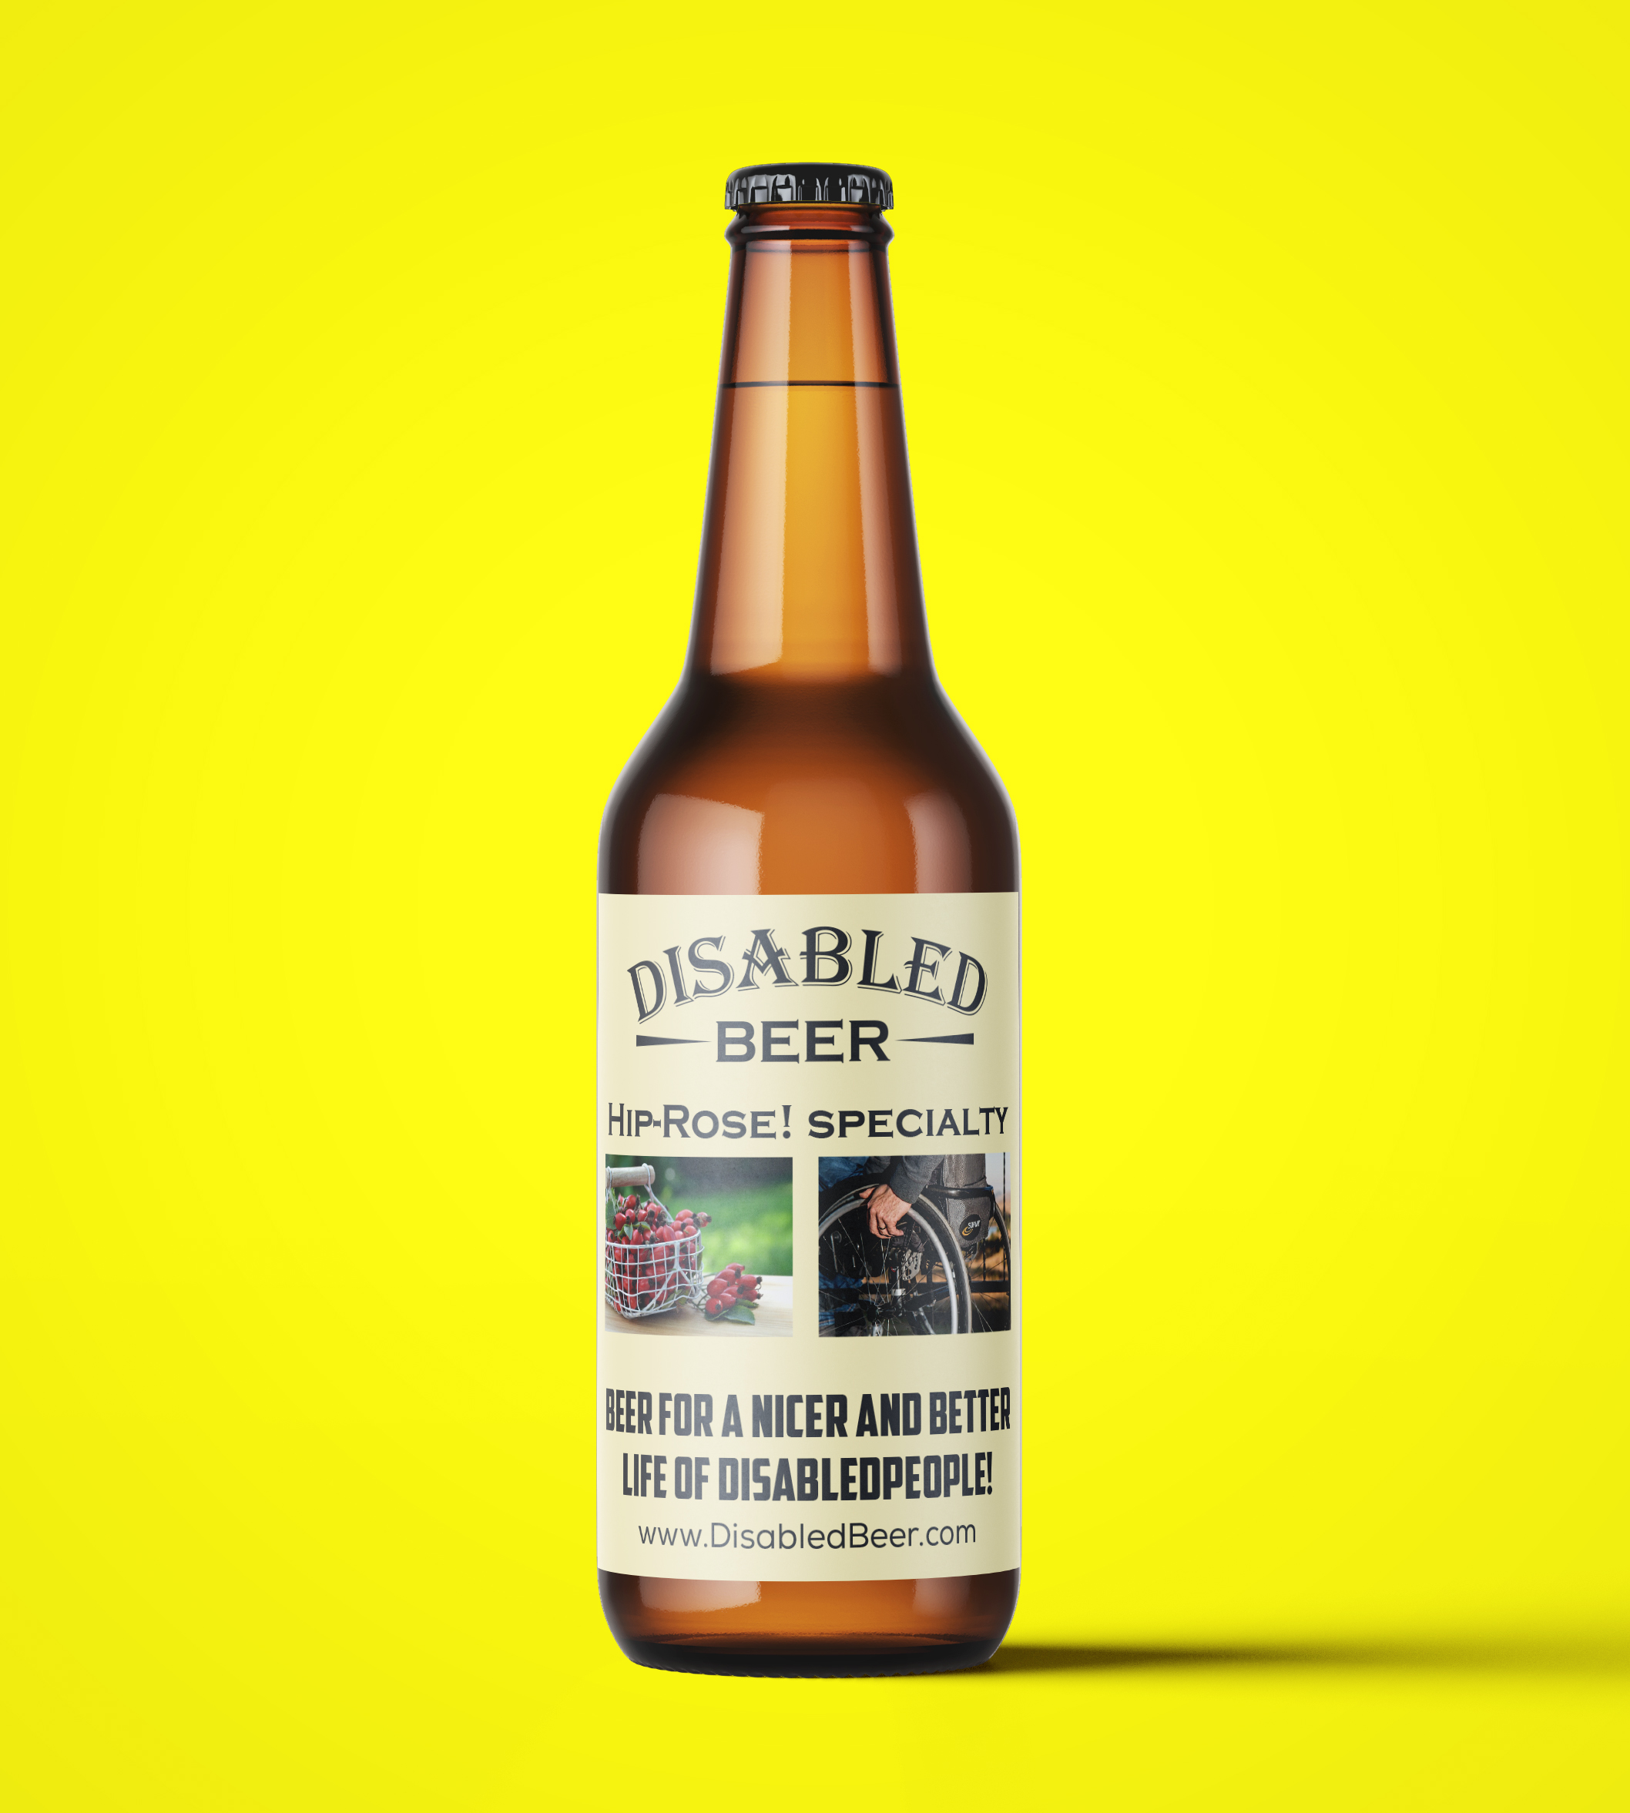
6.2 Results online survey “DisabledBeer.com”.
Results online survey “DisabledBeer.com” (November/December, 2020)

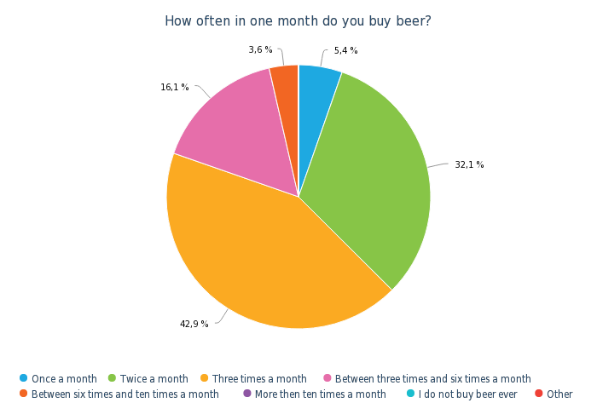

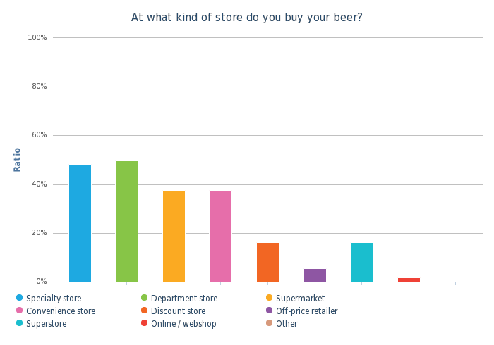

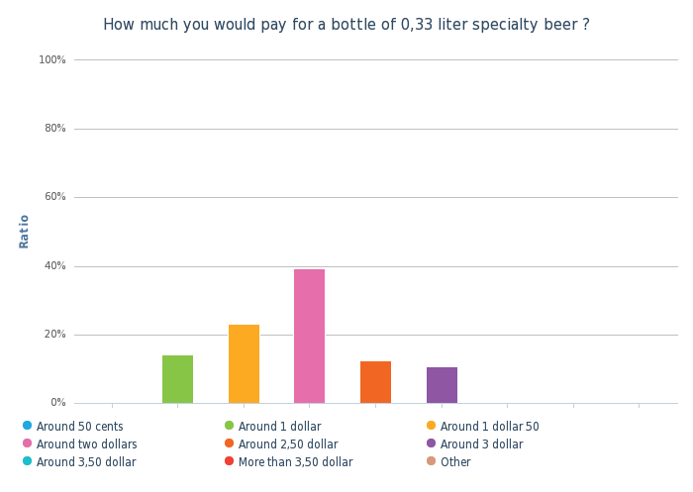

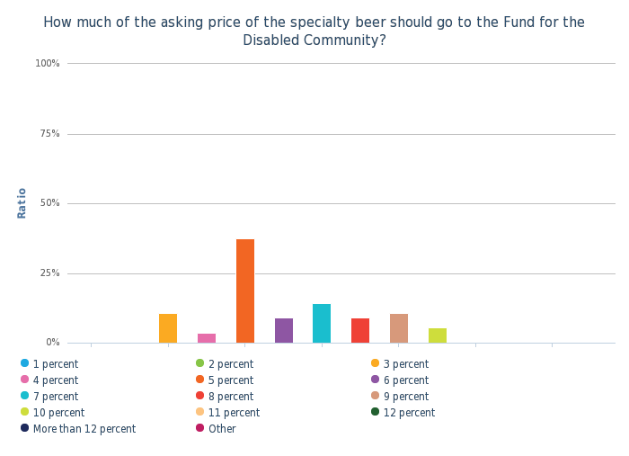

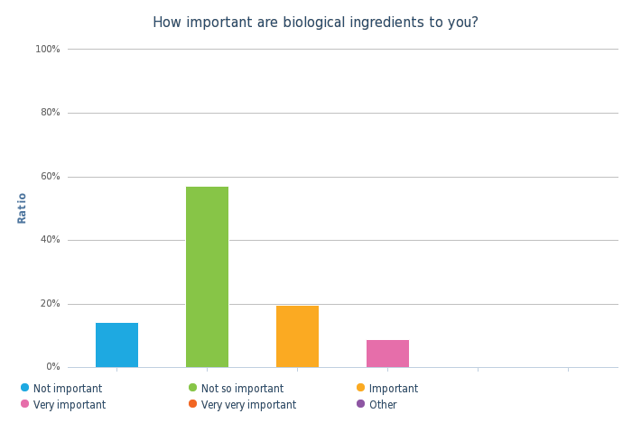

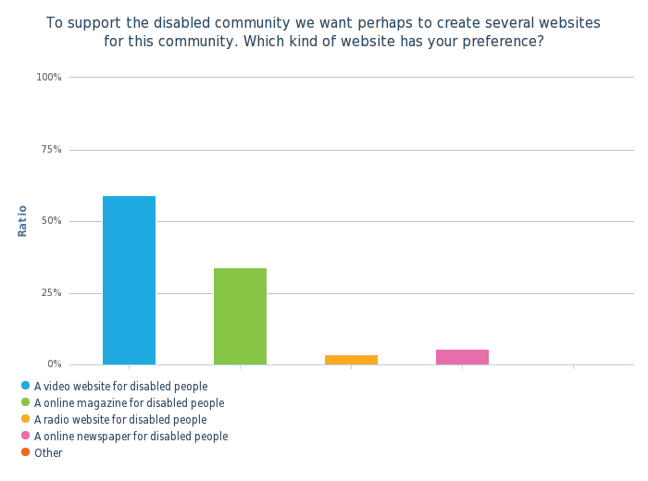

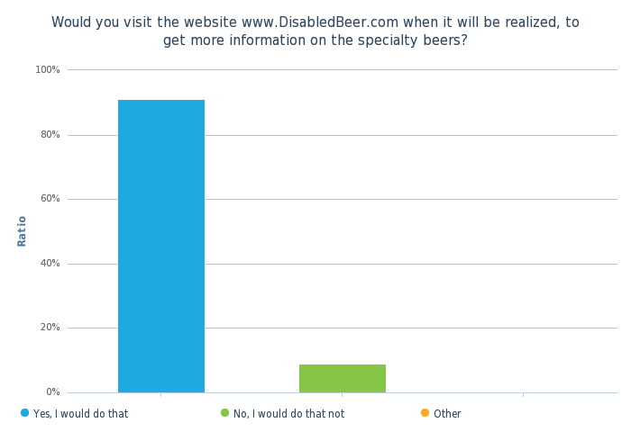

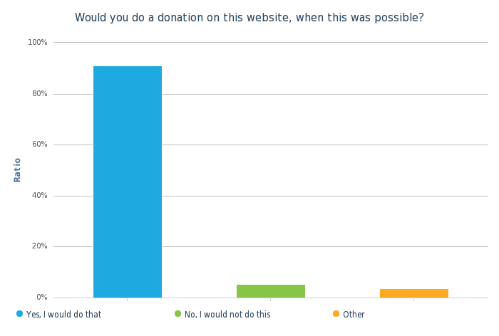

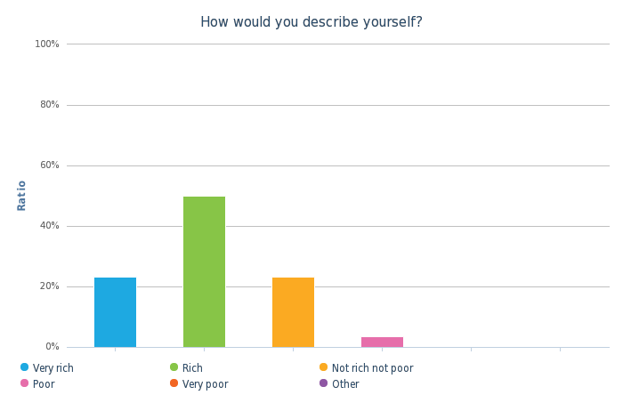

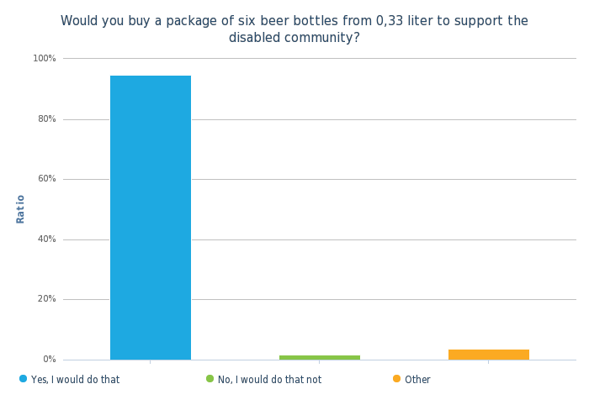
6.3 Internet addresses (large) retailers in the United States (USA):
RETAILER / SUPERMARKET: | INTERNET ADDRESS:
Safeway | www.safeway.com
Albertsons | www.albertsons.com
Vons | www.vons.com
Jewel-Osco | www.jewelosco.com
Ac Me Markets | www.acmemarkets.com
Shaw's and Star Market | www.shaws.com
Andronico's | www.andronicos.com
Carrs-Safeway | www.carrsqc.com
Haggen | www.haggen.com
Lucky Stores | www.luckysupermarkets.com
Pavilions | www.pavilions.com
Randalls | www.randalls.com
Tom Thumb | www.tomthumb.com
United Supermarkets | www.unitedsupermarkets.com
Food Lion | www.foodlion.com
Stop & Shop | www.stopandshop.com
Giant Food Stores | www.giantfoodstores.com
Hannaford Brothers Company | www.hannaford.com
Giant Food | www.giantfood.com
Harris Teeter | www.harristeeter.com
King Soopers | www.kingsoopers.com
Roundy's | www.roundys.com
Smith's Food and Drug | www.smithsfoodanddrug.com
Fred Meyer | www.fredmeyer.com
QFC | www.qfc.com
Ruler Foods | www.rulerfoods.com
City Market | www.citymarket.com
Baker's Supermarkets | -
Dillons | www.dillons.com
Fry's Food and Drug | www.frysfood.com
JayC Food Stores | www.jaycfoods.com
Marino's Fresh Market | www.marianos.com
Owen's Market | www.owensmarket.com
Pay Less Super Markets | www.pay-less.com
Ralph's | www.ralphs.com
Target Corporation | www.target.com
Walmart | www.walmart.com
Sam's Club | www.samsclub.com
(Source: wikipedia.org)
6.4 Questionnaire in English language:
PRODUCT QUESTIONNAIRE

Name or nickname: …
Date: …
Beername: …
Beerstyle: …
Alcohol percentage: …

Welcome to a special questionnaire about a special made beer. We want to know how much you appreciate the specialty beer. Taste the beer (sample) and take your time to create your opinion about the specialty beer. Thank you for particpating in this product questionnaire!

QUESTION 1 (EVERYTHING CONSIDERED):

Everything considered, how much do you “like” or “dislike” this beer overall?

( ) I like the beer extremely
( ) I like the beer very much
( ) I like the beer moderatley
( ) I like the beer slightly
( ) Neither like the beer nor dislike the beer
( ) I dislike the beer slightly
( ) I dislike the beer moderatley
( ) I dislike the beer very much
( ) I dislike the beer extremely

QUESTION 2 (EVERYTHING CONSIDERED):

In the case you liked something about the beer, what did you like about the beer?
(describe in words)

… … …
… … …

QUESTION 3 (EVERYTHING CONSIDERED):
In the case you disliked something about the beer, what did you disliked about the beer? (describe in words)
… … …
… … …

QUESTION 4 (TO LOOK):

What is your opinion about how the beer looks like?

( ) I like the appearance of the beer extremely
( ) I like the appearance of the beer very much
( ) I like the appearance of the beer moderatley
( ) I like the appearance of the beer slightly
( ) Neither like the appearance of the beer nor dislike the appearance of the beer
( ) I dislike the appearance of the beer slightly
( ) I dislike the appearance of the beer moderatley
( ) I dislike the appearance of the beer very much
( ) I dislike the appearance of the beer extremely

QUESTION 5 (TO LOOK):

How would you describe the color of the cookie?

( ) The color of the beer is much too light
( ) The color of the beer is somewhat too light
( ) The color of the beer is just about right
( ) The color of the beer is somewhat too dark
( ) The color of the beer is much too dark

QUESTION 6 (TO LOOK):

How much do you like the “clarity” of the beer?

( ) I like the “clarity” of the beer extremely
( ) I like the “clarity” of the beer very much
( ) I like the “clarity” of the beer moderatley
( ) I like the “clarity” of the beer slightly
( ) Neither like the “clarity” of the beer nor dislike the “clarity” of the beer
( ) I dislike the “clarity” of the beer slightly
( ) I dislike the “clarity” of the beer moderatley
( ) I dislike the “clarity” of the beer very much
( ) I dislike the “clarity” of the beer extremely

QUESTION 7 (TO LOOK):

How would you describe the “foam head” of the beer?

( ) I like the “foam head” of the beer extremely
( ) I like the “foam head” of the beer very much
( ) I like the “foam head” of the beer moderatley
( ) I like the “foam head” of the beer slightly
( ) Neither like the “foam head” of the beer nor dislike the “foam head” of the beer
( ) I dislike the “foam head” of the beer slightly
( ) I dislike the “foam head” of the beer moderatley
( ) I dislike the “foam head” of the beer very much
( ) I dislike the “foam head” of the beer extremely

QUESTION 8 (TO SMELL):

What do you found of the “smell intensity” of the beer?

( ) I like the “smell intensity” of the beer extremely
( ) I like the “smell intensity” of the beer very much
( ) I like the “smell intensity” of the beer moderatley
( ) I like the “smell intensity” of the beer slightly
( ) Neither like the “smell intensity” of the beer nor dislike the “smell intensity” of the beer
( ) I dislike the “smell intensity” of the beer slightly
( ) I dislike the “smell intensity” of the beer moderatley
( ) I dislike the “smell intensity” of the beer very much
( ) I dislike the “smell intensity” of the beer extremely
QUESTION 9 (TO SMELL):

What is your opinion about the “fruitiness” of the beer?

( ) I like the “fruitiness” of the beer extremely
( ) I like the “fruitiness” of the beer very much
( ) I like the “fruitiness” of the beer moderatley
( ) I like the “fruitiness” of the beer slightly
( ) Neither like the “fruitiness” of the beer nor dislike the “fruitiness” of the beer
( ) I dislike the “fruitiness” of the beer slightly
( ) I dislike the “fruitiness” of the beer moderatley
( ) I dislike the “fruitiness” of the beer very much
( ) I dislike the “fruitiness” of the beer extremely
( ) Otherwise / inapplicable

QUESTION 10 (TO SMELL):

What is your opinion about the overall “maltiness smell” of the beer?

( ) I like the “maltiness smell” of the beer extremely
( ) I like the “maltiness smell” of the beer very much
( ) I like the “maltiness smell” of the beer moderatley
( ) I like the “maltiness smell” of the beer slightly
( ) Neither like the “maltiness smell” of the beer nor dislike the “maltiness smell” of the beer
( ) I dislike the “maltiness smell” of the beer slightly
( ) I dislike the “maltiness smell” of the beer moderatley
( ) I dislike the “maltiness smell” of the beer very much
( ) I dislike the “maltiness smell” of the beer extremely
( ) Otherwise / inapplicable

QUESTION 11 (TO SMELL):

What is you opinion about the overall “spiciness” of this beer?

( ) I like the “spiciness” of the beer extremely
( ) I like the “spiciness” of the beer very much
( ) I like the “spiciness” of the beer moderatley
( ) I like the “spiciness” of the beer slightly
( ) Neither like the “spiciness” of the beer nor dislike the “spiciness” of the beer
( ) I dislike the “spiciness” of the beer slightly
( ) I dislike the “spiciness” of the beer moderatley
( ) I dislike the “spiciness” of the beer very much
( ) I dislike the “spiciness” of the beer extremely
( ) Otherwise / inapplicable

QUESTION 12 (TO SMELL):

Did you smell something other on the beer?

( ) Yes, namely …
( ) No

QUESTION 13 (TASTING):

How did you found the “sweetness” of the beer?

( ) I like the “sweetness” of the beer extremely
( ) I like the “sweetness” of the beer very much
( ) I like the “sweetness” of the beer moderatley
( ) I like the “sweetness” of the beer slightly
( ) Neither like the “sweetness” of the beer nor dislike the “sweetness” of the beer
( ) I dislike the “sweetness” of the beer slightly
( ) I dislike the “sweetness” of the beer moderatley
( ) I dislike the “sweetness” of the beer very much
( ) I dislike the “sweetness” of the beer extremely
( ) Otherwise / inapplicable

QUESTION 14 (TASTING):

How did you found the “sourness” of the beer?

( ) I like the “sourness” of the beer extremely
( ) I like the “sourness” of the beer very much
( ) I like the “sourness” of the beer moderatley
( ) I like the “sourness” of the beer slightly
( ) Neither like the “sourness” of the beer nor dislike the “sourness” of the beer
( ) I dislike the “sourness” of the beer slightly
( ) I dislike the “sourness” of the beer moderatley
( ) I dislike the “sourness” of the beer very much
( ) I dislike the “sourness” of the beer extremely
( ) Otherwise / inapplicable

QUESTION 15 (TASTING):

How did you found the “bitterness” of the beer?

( ) I like the “bitterness” of the beer extremely
( ) I like the “bitterness” of the beer very much
( ) I like the “bitterness” of the beer moderatley
( ) I like the “bitterness” of the beer slightly
( ) Neither like the “bitterness” of the beer nor dislike the “bitterness” of the beer
( ) I dislike the “bitterness” of the beer slightly
( ) I dislike the “bitterness” of the beer moderatley
( ) I dislike the “bitterness” of the beer very much
( ) I dislike the “bitterness” of the beer extremely
( ) Otherwise / inapplicable

QUESTION 16 (TASTING)

How did you found the “body” (light or full etc.) of the beer?

( ) I like the “body” of the beer extremely
( ) I like the “body” of the beer very much
( ) I like the “body” of the beer moderatley
( ) I like the “body” of the beer slightly
( ) Neither like the “body” of the beer nor dislike the “body” of the beer
( ) I dislike the “body” of the beer slightly
( ) I dislike the “body” of the beer moderatley
( ) I dislike the “body” of the beer very much
( ) I dislike the “body” of the beer extremely
( ) Otherwise / inapplicable

QUESTION 17 (TASTING)

How did you found the “content of CO2” of the beer?

( ) I like the “content of CO2” of the beer extremely
( ) I like the “content of CO2” of the beer very much
( ) I like the “content of CO2” of the beer moderatley
( ) I like the “content of CO2” of the beer slightly
( ) Neither like the “content of CO2” of the beer nor dislike the “content of CO2” of the beer
( ) I dislike the “content of CO2” of the beer slightly
( ) I dislike the “content of CO2” of the beer moderatley
( ) I dislike the “content of CO2” of the beer very much
( ) I dislike the “content of CO2” of the beer extremely
( ) Otherwise / inapplicable

QUESTION 18 (TASTING):

How would you describe the strength of the “aftertaste” of the beer?

( ) It was very pleasant
( ) It was somewhat pleasant
( ) It was neither pleasant or unpleasant
( ) It was somewhat unpleasant
( ) It was very unpleasant
( ) Not applicable

QUESTION 19 (TASTING)
In the case that you did taste something more, what was this:

( ) I did also taste (describe in words): …
( ) Inapplicable

QUESTION 20 (EVERYTHING CONSIDERED):

What kind of “report mark” will you give to this beer? Hereby is the report mark 1 extremely bad and the report mark 10 extremely good.

( ) Report mark 1
( ) Report mark 2
( ) Report mark 3
( ) Report mark 4
( ) Report mark 5
( ) Report mark 6
( ) Report mark 7
( ) Report mark 8
( ) Report mark 9
( ) Report mark 10

– End of questionnaire -

Thanks for your time to fill in the questionnaire!

(Source: partly, Sensory Evaluation of Food, Springer, 2010 and beerwulf.com)
6.5 Questionnaire in Dutch language:
PRODUCT VRAGENLIJST

Naam of nickname: …
Datum: …
Biernaam: …
Bierstijl: …
Alcoholpercentage: ...

Voor je ligt een vragenlijst over een speciaal gemaakte speciaal biertje. Wij willen graag van je weten wat je vindt van dit biertje. Bekijk, ruik en proef de (monster) uitgebreid en neem de tijd om een mening te vormen. We willen je alvast ontzettend bedanken voor je deelname.

VRAAG 1 (ALLES MEEGENOMEN):

Alles meegenomen, hoe waardeer je dit biertje?

( ) Waardeer het bierje extreem goed
( ) Waardeer het biertje erg goed
( ) Waardeer het biertje matig goed
( ) Waardeer het biertje licht goed
( ) Waardeer het biertje niet goed maar ook niet slecht
( ) Waardeer het biertje een beetje slecht
( ) Waardeer het biertje matig slecht
( ) Waardeer het biertje erg veel slecht
( ) Waardeer het biertje extreem slecht

VRAAG 2 (ALLES MEEGENOMEN):

In het geval dat je iets lekker vond aan het biertje, wat vond je dan lekker aan het biertje?
(beschrijf in woorden)

… … …
… … …

VRAAG 3 (ALLES MEEGENOMEN):
In het geval dat je iets niet lekker vond aan het biertje, wat vond je dan niet lekker aan het biertje? (beschrijf in woorden)
… … …
… … …

VRAAG 4 (KIJKEN):

Hoe vindt je het biertje er in het geheel uitzien?

( ) Vond het biertje er extreem goed uitzien
( ) Vond het biertje er goed uitzien
( ) Vond het biertje er matig goed uitzien
( ) Vond het biertje er een beetje goed uitzien
( ) Vond het biertje er niet goed uitzien maar ook niet slecht
( ) Vond het biertje er licht slecht er uitzien
( ) Vond het biertje er matig slecht uitzien
( ) Vond het biertje er erg slecht uitzien
( ) Vond het biertje er extreem slecht uitzien

VRAAG 5 (KIJKEN):

Hoe zou je de kleur van het biertje omschrijven?

( ) Veel te licht
( ) Een beetje te licht
( ) Ziet er precies goed uit
( ) Een beetje te donker
( ) Veel te donker
VRAAG 6 (KIJKEN):

In hoeverre waardeer je de “helderheid” van het biertje?

( ) Vond de helderheid van het biertje extreem goed
( ) Vond de helderheid van het biertje erg goed
( ) Vond de helderheid van het biertje matig goed
( ) Vond de helderheid van het biertje licht goed
( ) Vond de helderheid van het biertje niet goed maar ook niet slecht
( ) Vond de helderheid van het biertje licht slecht
( ) Vond de helderheid van het biertje matig slecht
( ) Vond de helderheid van het biertje erg slecht
( ) Vond de helderheid van het biertje extreem slecht

VRAAG 7 (KIJKEN):

Hoe zou je de “schuim” van het biertje omschrijven?

( ) Vond de schuim van het biertje extreem goed
( ) Vond de schuim van het biertje erg goed
( ) Vond de schuim van het biertje matig goed
( ) Vond de schuim van het biertje licht goed
( ) Vond de schuim van het biertje niet goed maar ook niet slecht
( ) Vond de schuim van het biertje licht slecht
( ) Vond de schuim van het biertje matig slecht
( ) Vond de schuim van het biertje erg slecht
( ) Vond de schuim van het biertje extreem slecht

VRAAG 8 (RUIKEN):

Wat vind je van de “intensiteit geuren” van het biertje?

( ) Vond de “intensiteit geuren” van het biertje extreem goed
( ) Vond de “intensiteit geuren” van het biertje erg goed
( ) Vond de “intensiteit geuren” van het biertje matig goed
( ) Vond de “intensiteit geuren” van het biertje licht goed
( ) Vond de “intensiteit geuren” van het biertje niet goed maar ook niet slecht
( ) Vond de “intensiteit geuren” van het biertje licht slecht
( ) Vond de “intensiteit geuren” van het biertje matig slecht
( ) Vond de “intensiteit geuren” van het biertje erg slecht
( ) Vond de “intensiteit geuren”van het biertje extreem slecht
VRAAG 9 (RUIKEN):

Wat vond je van de “fruitigheid geur” van het biertje?

( ) Vond de “fruitigheid geur” van het biertje extreem goed
( ) Vond de “fruitigheid geur” van het biertje erg goed
( ) Vond de “fruitigheid geur” van het biertje matig goed
( ) Vond de “fruitigheid geur” van het biertje licht goed
( ) Vond de “fruitigheid geur” van het biertje niet goed maar ook niet slecht
( ) Vond de “fruitigheid geur” van het biertje licht slecht
( ) Vond de “fruitigheid geur” van het biertje matig slecht
( ) Vond de “fruitigheid geur” van het biertje erg slecht
( ) Vond de “fruitigheid geur”van het biertje extreem slecht
( ) Anders / niet van toepassing

VRAAG 10 (RUIKEN):

Wat vind je van de “moutigheid geur” van het biertje?

( ) Vond de “moutigheid geur” van het biertje extreem goed
( ) Vond de “moutigheid geur” van het biertje erg goed
( ) Vond de “moutigheid geur” van het biertje matig goed
( ) Vond de “moutigheid geur” van het biertje licht goed
( ) Vond de “moutigheid geur” van het biertje niet goed maar ook niet slecht
( ) Vond de “moutigheid geur” van het biertje licht slecht
( ) Vond de “moutigheid geur” van het biertje matig slecht
( ) Vond de “moutigheid geur” van het biertje erg slecht
( ) Vond de “moutigheid geur” van het biertje extreem slecht
( ) Anders / niet van toepassing

VRAAG 11 (RUIKEN):

Wat vind je van de “kruidigheid geur” van dit biertje?

( ) Vond de “kruidigheid geur” van het biertje extreem goed
( ) Vond de “kruidigheid geur” van het biertje erg goed
( ) Vond de “kruidigheid geur” van het biertje matig goed
( ) Vond de “kruidigheid geur” van het biertje licht goed
( ) Vond de “kruidigheid geur” van het biertje niet goed maar ook niet slecht
( ) Vond de “kruidigheid geur” van het biertje licht slecht
( ) Vond de “kruidigheid geur” van het biertje matig slecht
( ) Vond de “kruidigheid geur” van het biertje erg slecht
( ) Vond de “kruidigheid geur” van het biertje extreem slecht
( ) Anders / niet van toepassing

VRAAG 12 (RUIKEN):

Ruik je nog meer aan dit biertje?

( ) Ja, namelijk...
( ) Nee
VRAAG 13 (PROEVEN):

Hoe vond je de “zoetigheid” van het biertje indien van toepassing?

( ) Vond de “zoetigheid” van het biertje extreem goed
( ) Vond de “zoetigheid” van het biertje erg goed
( ) Vond de “zoetigheid” van het biertje matig goed
( ) Vond de “zoetigheid” van het biertje licht goed
( ) Vond de “zoetigheid” van het biertje niet goed maar ook niet slecht
( ) Vond de “zoetigheid” van het biertje licht slecht
( ) Vond de “zoetigheid” van het biertje matig slecht
( ) Vond de “zoetigheid” van het biertje erg slecht
( ) Vond de “zoetigheid” van het biertje extreem slecht
( ) Anders / niet van toepassing

VRAAG 14 (PROEVEN):

Hoe zou je de “zuurheid” van dit biertje omschrijven?

( ) Vond de “zuurheid” van het biertje extreem goed
( ) Vond de “zuurheid” van het biertje erg goed
( ) Vond de “zuurheid” van het biertje matig goed
( ) Vond de “zuurheid” van het biertje licht goed
( ) Vond de “zuurheid” van het biertje niet goed maar ook niet slecht
( ) Vond de “zuurheid” van het biertje licht slecht
( ) Vond de “zuurheid” van het biertje matig slecht
( ) Vond de “zuurheid” van het biertje erg slecht
( ) Vond de “zuurheid” van het biertje extreem slecht
( ) Anders / niet van toepassing

VRAAG 15 (PROEVEN):

Hoe zou je de “bitterheid” van dit biertje omschrijven?

( ) Vond de “bitterheid” van het biertje extreem goed
( ) Vond de “bitterheid” van het biertje erg goed
( ) Vond de “bitterheid” van het biertje matig goed
( ) Vond de “bitterheid” van het biertje licht goed
( ) Vond de “bitterheid” van het biertje niet goed maar ook niet slecht
( ) Vond de “bitterheid” van het biertje licht slecht
( ) Vond de “bitterheid” van het biertje matig slecht
( ) Vond de “bitterheid” van het biertje erg slecht
( ) Vond de “bitterheid” van het biertje extreem slecht
( ) Anders / niet van toepassing

VRAAG 16 (PROEVEN):

Hoe zou je de “body” (licht of vol etc.) van dit biertje omschrijven?

( ) Vond de “body” van het biertje extreem goed
( ) Vond de “body” van het biertje erg goed
( ) Vond de “body” van het biertje matig goed
( ) Vond de “body” van het biertje licht goed
( ) Vond de “body” van het biertje niet goed maar ook niet slecht
( ) Vond de “body” van het biertje licht slecht
( ) Vond de “body” van het biertje matig slecht
( ) Vond de “body” van het biertje erg slecht
( ) Vond de “body” van het biertje extreem slecht
( ) Anders / niet van toepassing

VRAAG 17 (PROEVEN):

Hoe zou je het “koolzuurgehalte” (plat of bruisend etc.) van dit biertje omschrijven?

( ) Vond het “koolzuurgehalte” van het biertje extreem goed
( ) Vond het “koolzuurgehalte” van het biertje erg goed
( ) Vond het “koolzuurgehalte” van het biertje matig goed
( ) Vond het “koolzuurgehalte” van het biertje licht goed
( ) Vond het “koolzuurgehalte” van het biertje niet goed maar ook niet slecht
( ) Vond het “koolzuurgehalte” van het biertje licht slecht
( ) Vond het “koolzuurgehalte” van het biertje matig slecht
( ) Vond het “koolzuurgehalte” van het biertje erg slecht
( ) Vond het “koolzuurgehalte” van het biertje extreem slecht
( ) Anders / niet van toepassing
VRAAG 18 (PROEVEN):

Hoe zou je de “afdronk” van dit biertje omschrijven?

( ) Erg plezierig
( ) Een beetje plezierig
( ) Niet plezierig maar ook niet onplezierig
( ) Een beetje onplezierig
( ) Erg onplezierig
( ) Niet van toepassing
VRAAG 19 (PROEVEN)
Indien je nog meer proeft geef dan hieronder aan wat dit is:

( ) Ik proef ook: …
( ) Niet van toepassing

VRAAG 20 (ALLES MEEGENOMEN):

Welk rapportcijfer zou je dit biertje willen geven? Waarbij het cijfer 1 heel erg slecht is en het cijfer 10 heel erg goed is.

( ) Rapportcijfer 1
( ) Rapportcijfer 2
( ) Rapportcijfer 3
( ) Rapportcijfer 4
( ) Rapportcijfer 5
( ) Rapportcijfer 6
( ) Rapportcijfer 7
( ) Rapportcijfer 8
( ) Rapportcijfer 9
( ) Rapportcijfer 10

– Einde vragenlijst -

(Bron: partly, Sensory Evaluation of Food, Springer, 2010 en beerwulf.com)
6.6 Linkbuilding/SEO results for DisabledBeer.com website:
1: www.timebusinessnews.com-support-the-disabled-community-worldwide/
2: www.bloglovin.com/@supon/support-disabled-community-worldwide
3: www.launchora.com/story/support-disbaled-community-worldwide
6.7 List of possible to use “medicinal herbs” for beer recipes
1 Marigold (Goudsbloem)
2 Chamomile (Kamille)
3 Echinacea (Echinacea)
4 Valerian (Valeriaan)
5 Lavender (Lavendel)
6 St. John's wort (Sint-janskruid)
7 Roze hip (Rozebottel)
8 Hemp (Hennep)
9 Nettle (Brandnetel)
10 Ginseng (Ginseng)

(Source: vrijbuitersnest.nl)
--- End of Concept Businessplan “DisabledBeer.com”. Thanks for your attention!

